1. MySQL server details:

Local Server

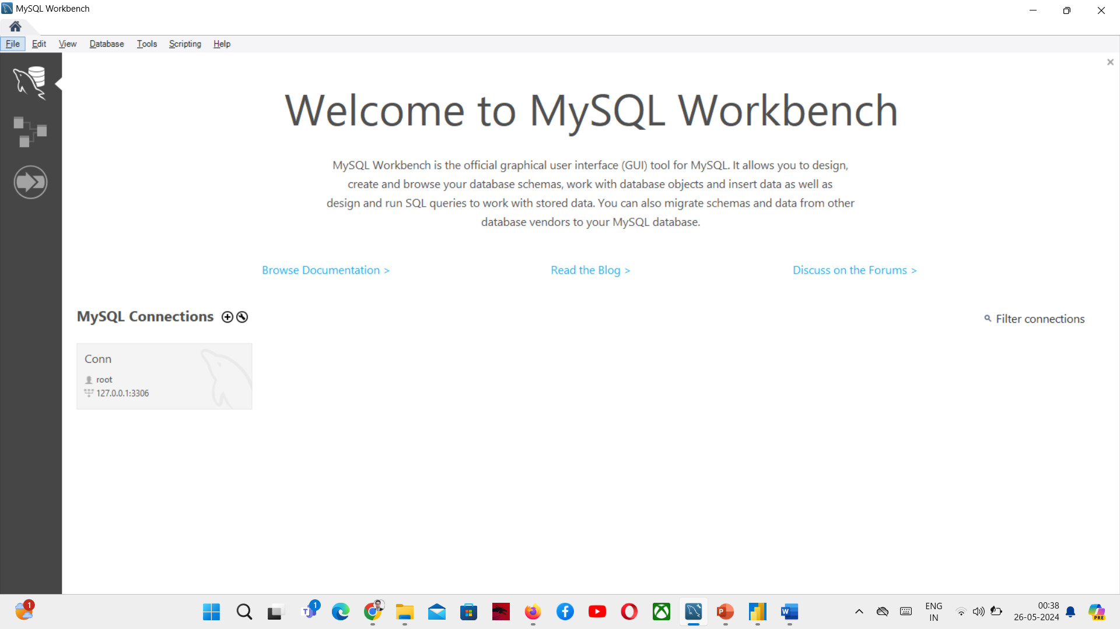

1. Database details

Database

1. Import Data to PowerBI. Use the server name, database name and the database credentials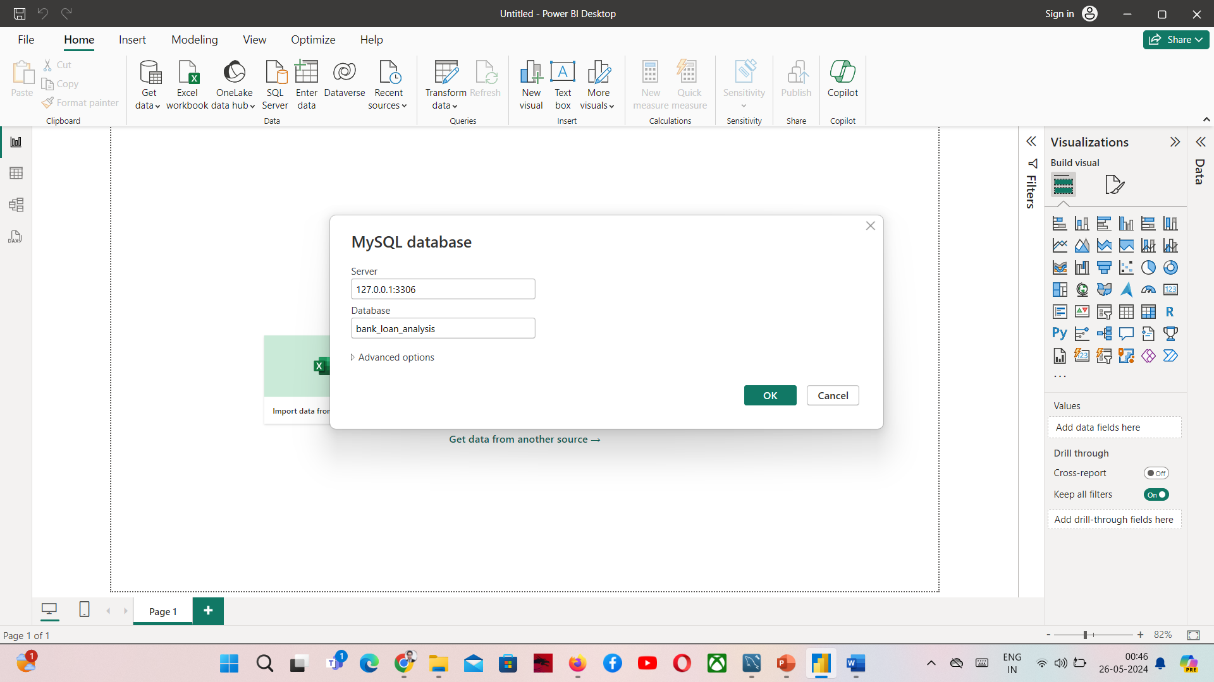

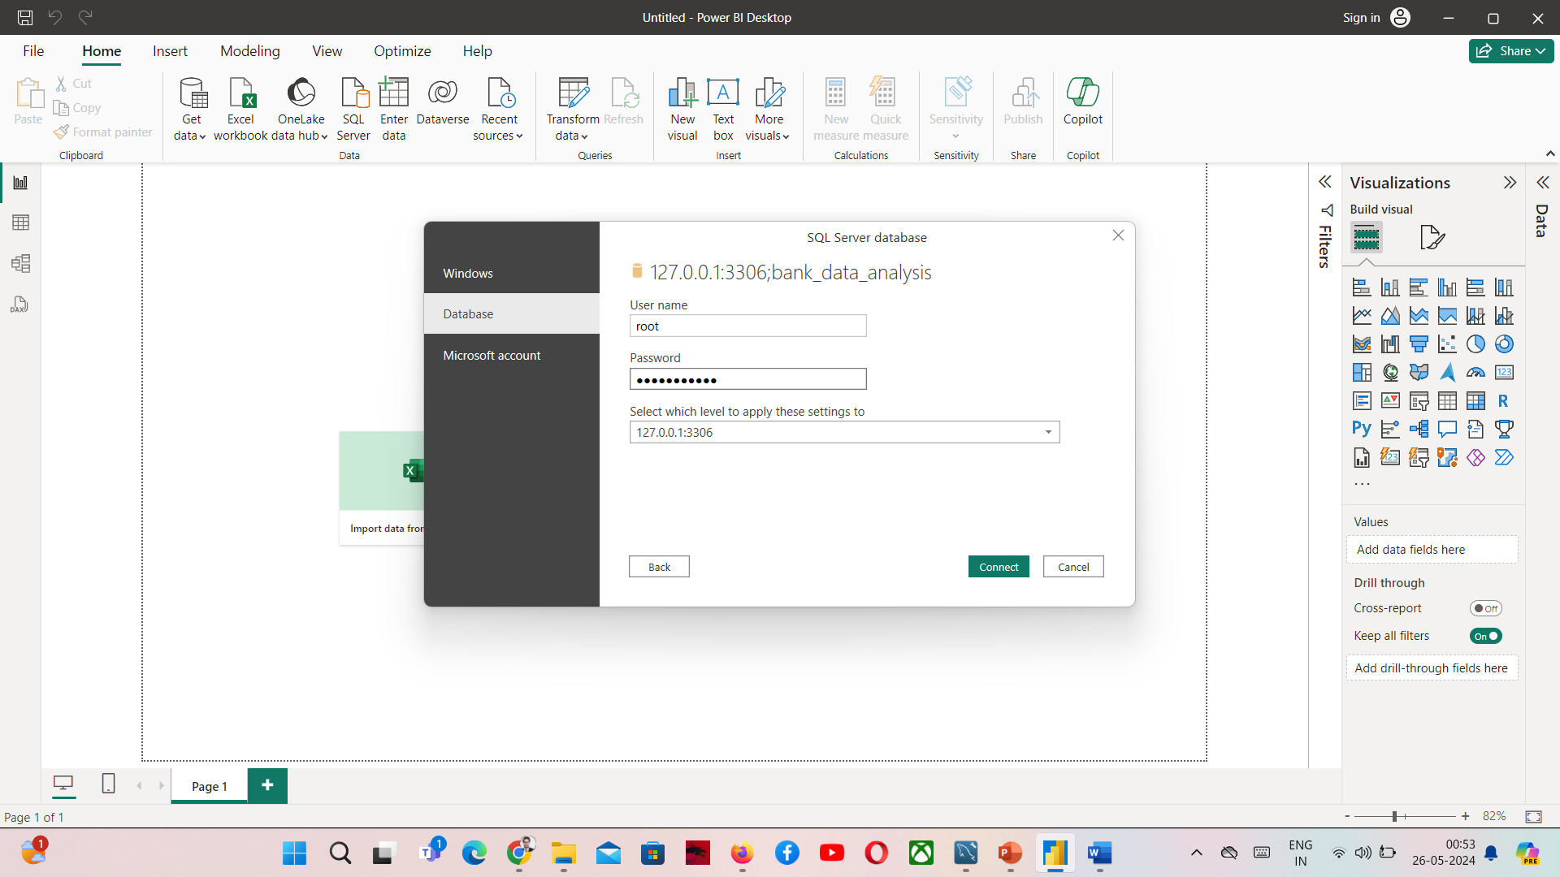

Click on load data.